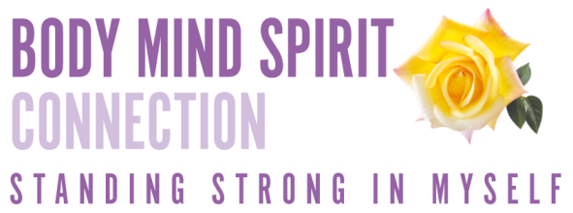 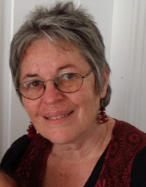

**When helping You is hurting Me.**

Trauma Exposure Response (Secondary Trauma)

How working with people affected by trauma affects us

Friday 5th August, 9.15am-3pm. $100

The Green Room. fsg Training Centre. Unit 11/8 Centre View Drive, Biggera Waters. Easy access, easy parking

* Simple tools and strategies to understand and process trauma,
* the impact of working with people who carry the toxic stress of unprocessed trauma,
* why you do the work you do and how to stay connected with the values you bring to this work,
* Develop strategies for self-care, safe connection and staying strong

**Minimise the ripple effects of trauma**

**For people who focus on others to focus on themselves.**

**Mindfulness and Mindsight.**

What is my stress like? When is stress more than stress?

Burnout, secondary trauma, PTSD

What gets in the way of looking after ourselves?

**MAKE A PLAN TO MINIMISE STRESS, MAXIMISE SELF CARE**

“Mary’s depth of knowledge, skills and experience enabled her to develop and conduct a workshop that was very beneficial to me in understanding my stress and providing tools for managing this. I highly recommend this workshop to others working in the mental health sector and other community service areas.” Mental Health Worker.

**Developed and presented by Mary Cutts B.A. Grad Dip Counselling**.

Mary has worked as counsellor, trainer, retreat and group facilitator for over 30 years. Her varied experience and deep understanding of neurobiology, trauma, attachment and Narrative Practices enable her to present trauma informed, strength based workshops in clear, safe and practical ways. She is a warm and gifted facilitator, combining information, group process and individual reflection.

**Calm under Fire.**

Helping parents, youth workers, carers and teachers understand the chemical reaction that happens between a young person fired by unprocessed trauma and unmet needs (abuse and neglect) and their carers.

Strategies to provide the calm young people need to process their experiences and learn new ways of being

Staying in touch with ourselves, values, feelings, bodies.

The neuroscience of Mindfulness, Mindsight and Connection.

**Friday 29th July, 9am-1pm. $80**

**The Green Room, fsg 11/8 Centre View Drive, Biggera Waters.**

**Becoming Again**

Understanding the effects and coping strategies of those who have experience child sexual abuse.

The importance of putting the event in context

Understanding resistance; what a child does to cope.

Understanding the healing process; of not one but many stories.

**Friday 19th August. 9am-1pm $80**

**The Green Room fsg 11/8 Centre View Drive, Biggera Waters**

“Your workshops on Trauma will help people to better understand themselves – that’s what that one workshop did for me. So, thank you”. Family Worker

**Healing Retreats.** **2, 3 or 4 day individual Retreats.**

Time out from day to day lives to process stress, trauma and burnout .**I am not what has happened to me, I am what is important to me.**

“My retreat was life changing and life-saving. To value self and give time to self, helped my journey to find and accept myself.”

Contact 0403348720 or

[mary@bmsconnection.com.au](mailto:mary@bmsconnection.com.au)

Registrations to be received no later than a week before the workshop. Morewww.bmsconnection.com.au

**Standing Strong in who I am.**

Restoring the me-ness after tough times.

A workshop for people who have been through tough times.

A safe nurturing day to connect with who you are and what is important to you. Restore body, mind and spirt.

Some experiences require us to live in survival mode, (coping with daily experience of death and trauma, living or working alongside people with terminal or mental illness or posttraumatic stress, coping with a crisis that lasts a long time, getting safe after abuse or bullying at home or work, experiencing relational trauma)

Teachers, nurses, youth workers, parents, paramedics, police, confronting daily trauma.

**Restore that sense of self and well-being that times of surviving whittle away.**

**Friday 12th August, 9.15am-3pm. $110**

**The Green Room fsg Training Centre. Unit 11/8 Centre View Drive, Biggera Waters.**

Easy access and parking

Inspired by “The Tree of Life”